A000-AM,C-Costa Rica-Vessel Fragment

Pre-Columbian Mayan Terracotta Vessel leg fragment with traditional head figure  9.1cm x 7.8cm x 5.9cm some trace of original paint Costa Rica..Circa 300-800AD   
from a large Tucson Arizona Professors Collection  
 collected in the 1950"s **CAA-16**   
Authenticity is guaranteed

Case no. 14

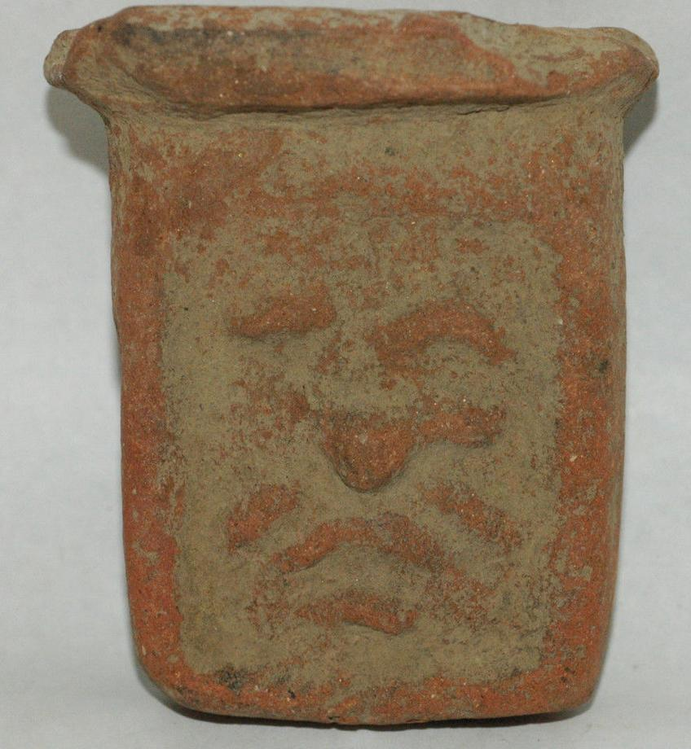 US $49.95